

A PROJECT REPORT
ON

“RareDetect: AI Based System for Identifying Rare Brain Tumors”

FOR THE DEGREE OF
BACHELOR OF ENGINEERING IN COMPUTER ENGINEERING
SUBMITTED BY
Rushikesh S. Shiraskar [4107] Rutuja Nandu Londhe [4108] Samruddhi H. Sabale [4110] Piyush Santosh Borade [4118]
UNDER THE GUIDANCE OF
Prof. S.C. Patle


DEPARTMENT OF COMPUTER ENGINEERING
Jayawant Shikshan Prasarak Mandal’s Jayawantrao Sawant College Of Engineering Hadapsar, Pune 411028
AFFILIATED TO

SAVITRIBAI PHULE PUNE UNIVERSITY YEAR 2025–26



DEPARTMENT OF COMPUTER ENGINEERING
JSPMs Jayawantrao Sawant College of Engineering, Pune
Hadapsar, Tal-Haveli, Pin- 411028, India

CERTIFICATE
This is to certify that the Project report entitled

“RareDetect: AI Based System for Identifying Rare Brain Tumors”
Submitted by

Mr. Rushikesh S. Shiraskar Exam No. Ms.Rutuja Nandu Londhe Exam No. Ms. Samruddhi H. Sabale Exam No.
Mr. Piyush Santosh Borade Exam No.

This is a bonafide work carried out under the supervision of Prof. R. V. Shinde and it is submitted towards the partial fulfillment of the requirement of Savitribai Phule Pune University, Pune for the award of the degree of Bachelor of Engineering in Computer Engineering, at JSPM’S Jayawantrao Sawant College of Engineering, Pune.

Prof.S. C. Patle External Examiner
Internal Guide

Prof.S. B. Chaudhari Dr. P. D. Lambhate

Project Coordinator Head of Department

Dr. P. A. Patil
Principal

ACKNOWLEDGEMENT

As a wise person once said about the nobility of the teaching profession,” Catch a fish, and you feed a man for dinner, but teach a man how to catch a fish, and you feed him for life.”

We would like to express our gratitude to our Project guide Prof. S. C. Patle who has been an unwavering source of inspiration and assistance. She not only encourages us to undertake this project but also provided valuable guidance through- out its duration, offering support during challenging times.
We are also deeply grateful to Prof. A. S. Dikale , Dr. S. B. Chaudhari our project coordinator, for their exceptional support and guidance, which played a pivotal role in the success of this assignment.
We are also grateful to Prof. Dr. P. D. Lambhate, Head of Computer Engineering Department, JSCOE for her indispensable support and suggestions.
We are also grateful to Dr.P.A.Patil, Principal of JSCOE for his indispensable support and suggestions.
Furthermore, we extend our gratitude to all the faculty members of the Computer Engineering Department. Their assistance and willingness to go the extra mile were instrumental in our efficient completion of this project, and they consistently supported us during times of need.

Rushikesh Shiraskar Rutuja Nandu Londhe Samruddhi H. Sabale Piyush Santosh Borade
(B. E. Computer Engineering) JSCOE, Pune.

Index

- Introduction 1
    - Real-Time Hazard Detection 1
    - Challenges in Traditional Surveillance Infrastructure 1
    - Machine Learning for Detection and Prediction 2
  - Motivation 2
  - Objectives 2
- Literature Survey 3
  - Comparison Table 4
- Problem Definition and Scope 5
  - Problem Statement 5
  - Project Scope 5
  - Mathematical Model 6
- System Design and Implementation 7
  - Introduction 7
    - Architecture Diagram 7
    - Flow Chart 8
  - System’s UML diagrams 9
    - Use Case Diagram 9
    - UML Component Diagram 10
    - Data Flow Diagram 12
    - Activity Diagram 13
4.2.6 Class Diagram 14
  - Implementation Details… 15
  - System Features 20
  - Implementation Constraints 21
- Software Requirement and Specification 22
  - Introduction 22
  - Algorithm Selection 22
  - Hardware Requirements 23
  - Software Requirements 23
  - Software Quality Attributes 24
- Project Plan 25
  - Project Plan 25
  - SDLC 26
- Result Analysis 27
- Technical Specification 28
  - Advantages 28
  - Disadvantages 28
  - Applications 28
- Conclusion 29
- References 30

Chapter 1 : Introduction
1.1 Introduction
The emergence of Artificial Intelligence (AI) and Machine Learning (ML) in the medical domain has revolutionized the process of disease diagnosis and analysis through medical imaging such as MRI, CT, and X-ray scans. Among these, deep learning-based image classification has demonstrated remarkable success, enabling models to identify intricate visual patterns that often go unnoticed by the human eye. However, a critical challenge remains in the detection and classification of rare brain diseases, particularly in neuroimaging, where MRI scans of tumors like glioma, meningioma, and pituitary tumor exhibit overlapping and complex characteristics. The rarity of such cases results in limited data availability, poor model generalization, and increased chances of misclassification.
To address these challenges, the project “RareNet: Comparative CNN-Based Analysis for Rare Disease Classification” proposes a robust solution that employs a custom deep learning model designed specifically for classifying MRI brain scans into four key categories — glioma, meningioma, pituitary tumor, and no tumor. The system will leverage open-source datasets, perform extensive preprocessing (resizing, normalization, and augmentation), and compare the proposed custom CNN model’s performance with established architectures such as VGG16 and ResNet50 using evaluation metrics including accuracy, precision, recall, and F1-score.
The objective of the project is to create an efficient and scalable AI model that enhances diagnostic accuracy for rare brain tumor cases. By providing reliable classification and interpretability, the system aims to support clinical professionals in early-stage tumor identification, thus improving decision-making in real-world healthcare environments.

1.1.1 Demand and Forecast
The demand for AI-driven brain tumor detection and classification systems has risen sharply due to the global shortage of radiologists and the rapid increase in MRI scans requiring expert analysis. Manual examination of medical images is not only time-intensive but also susceptible to human error, particularly in under-resourced or rural medical facilities.
The AI in medical imaging market was valued at approximately USD 1.5 billion in 2024 and is projected to reach USD 20 billion by 2033, expanding at a compound annual growth rate (CAGR) of around 30–35%. AI-assisted diagnostic systems for detecting glioma, meningioma, and pituitary tumors are increasingly being adopted by hospitals, diagnostic centers, and telemedicine platforms for efficient and early diagnosis.
Over the next decade, these systems are expected to become integral components of modern healthcare infrastructure, facilitating automated, accurate, and faster diagnosis. They will contribute to improving early detection rates, reducing diagnostic delays, and minimizing disparities in healthcare accessibility between urban and rural regions.

1.1.2 Challenges of Infrastructure
While AI-based brain tumor detection offers tremendous potential, its practical implementation encounters several infrastructural and operational barriers:
- Lack of advanced MRI machines in rural hospitals for high-resolution imaging.
- Insufficient computational infrastructure to train and deploy deep learning models efficiently.
- Limited and unreliable internet connectivity in remote regions, hindering cloud-based processing.
- Shortage of data storage and management systems for large-scale MRI datasets.
- Limited technical support for AI system maintenance, calibration, and model updates.
- Integration difficulties between AI-based diagnostic tools and existing hospital management systems.

1.1.3 Machine Learning for Prediction
Machine Learning (ML) provides a powerful computational approach that enables systems to learn patterns from medical data and make predictions without explicit programming. In MRI-based brain imaging, ML algorithms analyze complex spatial and textural patterns within brain tissues to identify tumor presence and type.
The system is trained on labeled MRI datasets containing samples of glioma, meningioma, pituitary tumors, and healthy brains. During training, the model extracts significant features such as tissue intensity, structural deformation, and edge variations to develop a high-dimensional feature representation. This learned representation is then applied to new, unseen MRI scans for classification, where the model assigns probabilities to each tumor class based on learned features.
Performance evaluation of the trained models is conducted using metrics such as accuracy, precision, recall, and F1-score, which collectively assess the model’s predictive reliability. Deep learning models, unlike traditional methods, can detect minute abnormalities that may escape manual diagnosis, offering enhanced speed and consistency in medical image interpretation.
Furthermore, continuous learning from new MRI data enables adaptive improvement of model accuracy over time, ensuring robustness across diverse scanners and imaging conditions. Such systems serve as vital diagnostic assistants, especially in regions with limited access to experienced radiologists, thereby enabling scalable, consistent, and accurate brain tumor classification.

1.2 Motivation
Accurate and timely identification of brain tumors is essential for improving treatment outcomes and patient survival. Yet in many regions, diagnosis still relies on manual MRI interpretation—slow, error-prone, and dependent on scarce radiology experts. The growing volume of imaging data further strains healthcare systems, making timely review difficult. RareNet addresses this gap by leveraging AI and deep learning to automate tumor detection and classification with high accuracy and interpretability. By reducing diagnostic workloads, minimizing errors, and enabling real-time support, RareNet aims to democratize access to intelligent healthcare. Ultimately, it fosters early detection, streamlines clinical workflows, and contributes to inclusive, efficient patient care worldwide.

1.3 Objective
- To develop a custom CNN-based model for classifying MRI brain scans into four categories — glioma, meningioma, pituitary tumor, and no tumor.
- To utilize publicly available medical image datasets and apply preprocessing steps such as resizing, normalization, and augmentation for optimal model performance.
- To train and evaluate pretrained architectures such as VGG16 and ResNet50, and compare their performance with the proposed model.
- To demonstrate how the proposed custom CNN enhances reliability and sensitivity in detecting rare tumor types.
- To support early-stage diagnosis and clinical decision-making through a robust, efficient, and interpretable AI-based classification system.

Chapter 2 : LITERATURE SURVEY

Yakub Bhanothu et al. (2021) proposed a CNN-based model for MRI brain tumor detection using data augmentation to enhance accuracy. Their system effectively classified tumor types but did not compare results across different pretrained models, leaving scope for multi-architecture benchmarking.[1]

Md Ishtyaq Mahmud et al. (2022) conducted a comparative study between VGG16 and ResNet50 for brain MRI classification. Their findings revealed that ResNet50 achieved higher accuracy and stability due to its residual connections. However, the research focused on comparison only and did not attempt to design an improved model. [2]

- Jeenath Shafana and A. Senthil Selvi (2020) designed a lightweight custom CNN architecture optimized for small and imbalanced datasets. The model performed well for rare tumor cases by reducing overfitting but lacked direct comparison with standard architectures like VGG16 and ResNet50.[3]

Anurag Goswami and Manish Dixit (2020) presented a detailed study of MRI segmentation methods to enhance tumor localization before classification. Their work improved preprocessing accuracy and provided a stronger foundation for classification but did not address architectural or performance improvements in CNN models.[4]

Comparison Table

Sr. No. | Paper Title | Focus Area | Proposed Technique | Relevance to Our Project
1 | Brain Tumor Detection using Deep Neural Networks (2021) | CNN for MRI-based tumor detection | Custom CNN model with data augmentation for improved accuracy | Establishes CNN as baseline; lacks multi-model comparison
2 | Comparative Analysis of VGG16 and ResNet50 for Brain MRI Classification (2022) | Transfer learning models (VGG16, ResNet50) | Benchmarks both models; ResNet50 performs better | Provides baseline for comparative evaluation
3 | Custom CNN Architecture for Rare Brain Tumor Detection (2020) | Lightweight CNN for small datasets | Custom CNN optimized for rare classes and low data availability | Inspires RareNet’s approach for rare tumor classification
4 | An Analysis of Image Segmentation Methods for Brain Tumour Detection (2020) | Preprocessing and segmentation | Comparative study of MRI segmentation methods | Helps refine preprocessing for RareNet dataset preparation

Table 2.1 – Reference Paper Comparison Table

Chapter 3 PROBLEM DEFINATION AND SCOPE

Problem Definition

Brain tumors pose a serious threat to human health, and early diagnosis is crucial for effective treatment. Conventional diagnostic procedures rely heavily on manual MRI interpretation by radiologists, which is time-consuming and prone to human error. Although deep learning has improved classification accuracy in medical imaging, existing systems face limitations when detecting rare tumor classes due to limited datasets, class imbalance, and the high computational cost of large models.
Many current approaches focus on single CNN architectures or pretrained models without addressing performance variation across architectures. There is a need for a comparative framework that not only benchmarks existing models but also proposes a custom CNN optimized for rare tumor classification with high reliability and low overfitting.

Problem Statement:
To design and develop a deep learning-based system for brain tumor detection and classification using MRI images, incorporating custom CNN architecture and comparative evaluation with VGG16 and ResNet50, to achieve improved accuracy and reliability in detecting rare and underrepresented tumor types.

Project Scope

The proposed system aims to provide a comprehensive, real-time, and scalable disaster detection framework that combines IoT-based sensing, machine learning prediction, and cloud-enabled communication. It focuses on continuous environmental monitoring, intelligent analysis, and automatic alert generation for proactive disaster management.

In-Scope:

    - Implementation of custom CNN architecture for classifying MRI brain scans into four categories: glioma, meningioma, pituitary tumor, and no tumor.
    - Use of pretrained deep learning models (VGG16 and ResNet50) for performance benchmarking.
    - Dataset preprocessing involving resizing, normalization, and data augmentation to handle variability and class imbalance.
    - Evaluation using key performance metrics: accuracy, precision, recall, and F1-score.
    - Comparative visualization through confusion matrices, accuracy graphs, and performance tables.
    - Analysis of model behavior on rare class instances to evaluate stability and generalization.
    - Development of a user-friendly visualization interface (optional) for MRI image classification results.

Mathematical Model
Step 1: Data Preprocessing
This labeled dataset is used for supervised model training.All MRI images are preprocessed to ensure uniformity before training.
Resizing images to a fixed input size.
Normalizing pixel intensity values to a range between 0 and 1.
Performing data augmentation such as rotation, flipping, and zooming to prevent overfitting
This stage ensures that all input images are standardized for accurate learning.

Step 2: Feature Extraction
The processed images are passed through convolutional layers of the CNN to extract deep spatial and textural features.
These features represent tumor patterns such as edges, texture, and intensity differences, which are critical for distinguishing tumor types.

Step 3: Model Training
During model training, the extracted features are used to adjust the model’s internal parameters (weights and biases) using backpropagation.
The training process minimizes the loss between predicted and actual tumor labels.Custom CNN ,VGG16 (pretrained) ,ResNet50 (pretrained)
The dataset is divided into training, validation, and testing subsets to evaluate performance and prevent overfitting.

Step 3: Model Training
During model training, the extracted features are used to adjust the model’s internal parameters (weights and biases) using backpropagation.
The training process minimizes the loss between predicted and actual tumor labels.Custom CNN ,VGG16 (pretrained) ,ResNet50 (pretrained)
The dataset is divided into training, validation, and testing subsets to evaluate performance and prevent overfitting.

Step 4: Machine Learning Prediction Model
Once trained, the model predicts the class of a new MRI image.
The output classes are:
0 – No Tumor
1 Tumor
The model assigns probability scores to each class and selects the one with the highest confidence value as the final prediction.

Step 5: Decision Function
If the predicted probability for a class is greater than or equal to the defined threshold (e.g., 0.5), the model confirms the classification; otherwise, the image is flagged for manual review.
This ensures that only confident predictions are accepted as final results.

Step 6: Result and Evaluation
If the predicted probability for a class is greater than or equal to the defined threshold (e.g., 0.5), the model confirms the classification; otherwise, the image is flagged for manual review.
This ensures that only confident predictions are accepted as final results.The model’s performance is evaluated using key metrics: Accuracy ,Precision, Recall, F1-Score
The comparative results of Custom CNN, VGG16, and ResNet50 are analyzed to determine which model performs best for rare tumor detection.

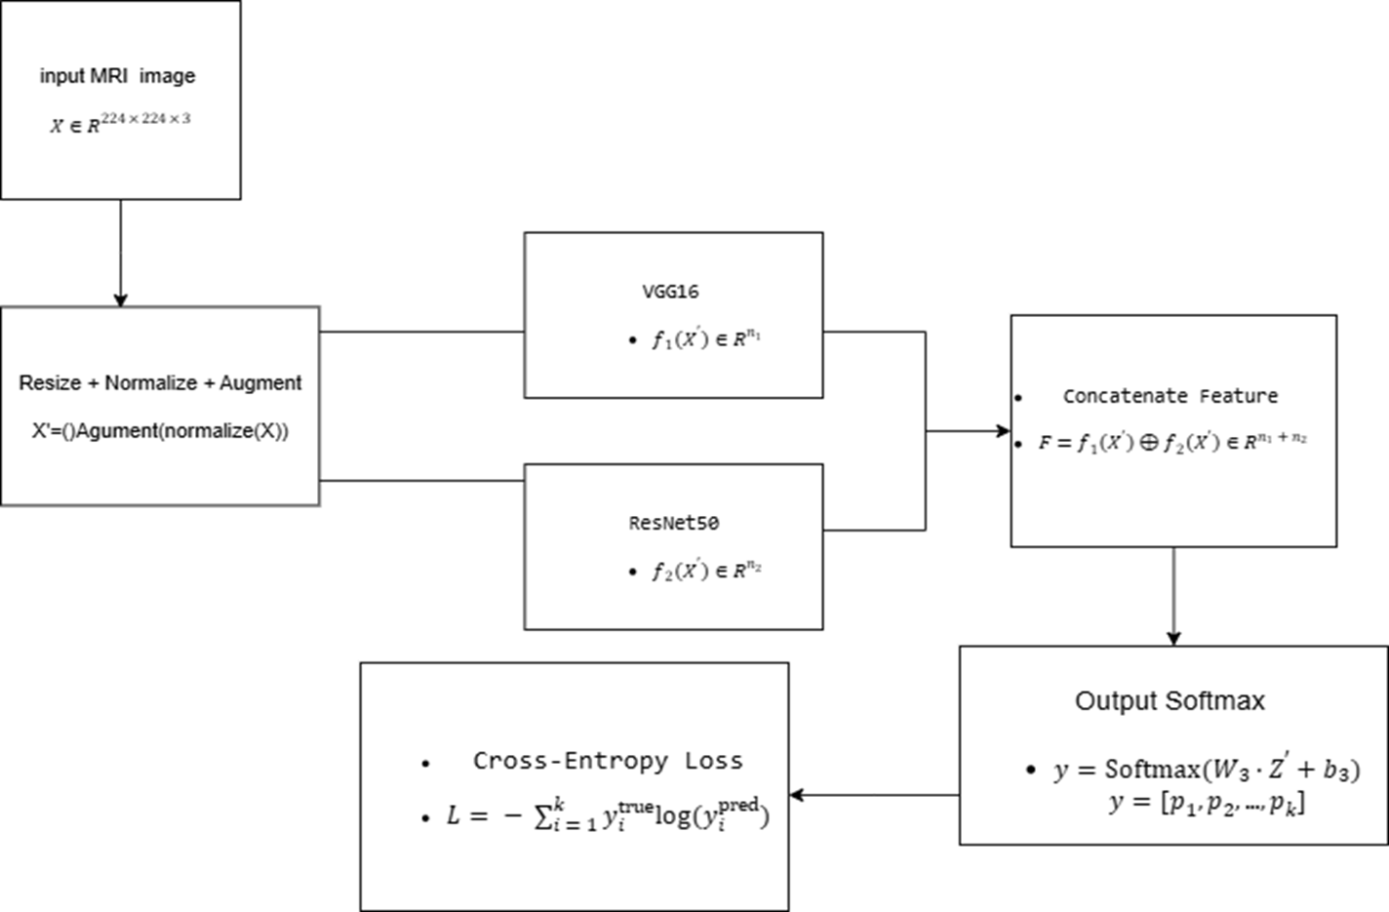

Fig.3.3.1-Mathematical Model Flow Diagram

CHAPTER 4: System Design and Implementation

Introduction
System design acts as the architectural blueprint for the RareNet project. It bridges the conceptual framework of deep learning-based brain tumor detection with its practical implementation.
The system is designed to automate the classification of brain MRI images into four distinct categories: glioma, meningioma, pituitary tumor, and no tumor using Convolutional Neural Networks (CNNs) and pretrained models such as VGG16 and ResNet50.
The primary aim of this design is to ensure accuracy, scalability, and efficient execution while maintaining minimal computational complexity.
The implementation has been carried out using Python and deep learning libraries such as TensorFlow and Keras for model building, training, and evaluation.

Design Model

Input Data Layer

  - MRI images are collected from public medical datasets containing tumor and non-tumor cases
  - Each image is resized and normalized before being fed into the network
  - The dataset is divided into training, validation, and testing subsets to ensure robust model evaluation

Processing Layer

  - Image enhancement operations such as normalization and augmentation (rotation, flipping, zooming) are performed.
  - This step ensures better generalization and reduces overfitting in the deep learning model.

Feature Extraction Layer

  - CNN layers automatically extract important features such as edges, intensity variations, and tumor boundaries.
  - Pretrained models (VGG16 and ResNet50) are used to extract higher-level features through transfer learning.
  - The custom CNN architecture performs hierarchical feature extraction with reduced parameters for faster computation

Classification Layer
  - Extracted features are passed through fully connected layers to classify MRI images into one of the four classes
  - Activation functions such as ReLU and Softmax are used for nonlinear transformation and probability assignment.

Evaluation and Comparison Layer
  - The performance of Custom CNN, VGG16, and ResNet50 is compared using metrics like accuracy, precision, recall, and F1-score.
  - Results are visualized through graphs and confusion matrices to analyze strengths and weaknesses of each model.

·

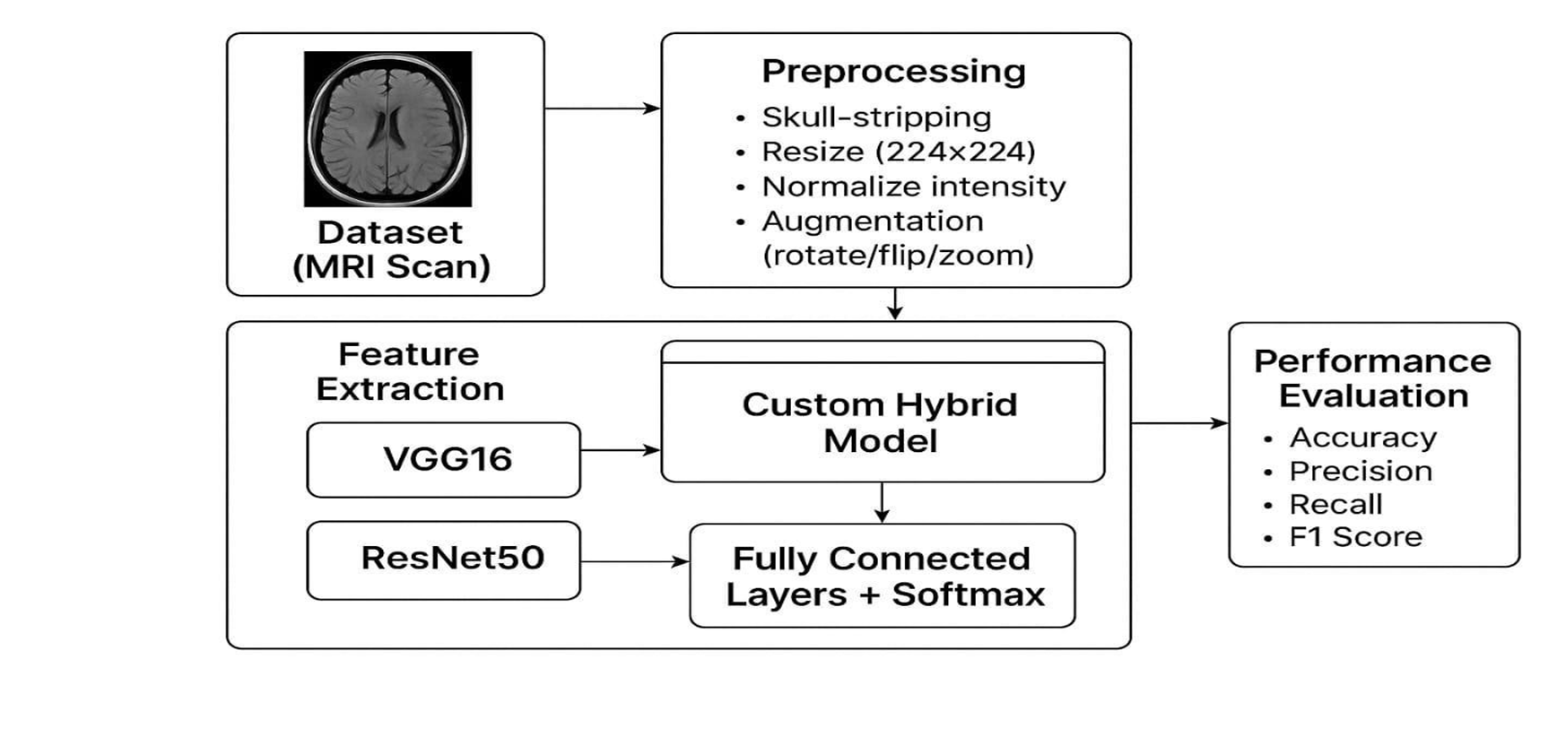
Fig 4.2.1 – System Architecture

UML Diagrams
      - Class Diagram
- Class Diagram Overview This Class Diagram outlines the static architecture of an AI-based MRI image analysis system for brain tumor classification. It defines key system classes, their attributes, methods, and interactions, enabling a clear understanding of how the system processes medical images from acquisition to report generation.
- MRIImage Class Manages MRI image data including image ID, raw image, and label. It supports loading, preprocessing, and saving of MRI scans.
- Preprocessor Class Handles image preprocessing tasks such as resizing, normalization, augmentation, and skull stripping. It prepares raw images for feature extraction.
- FeatureExtractor Class Extracts meaningful features from preprocessed images using specified extractor types and pretrained weights. It also loads pretrained models for analysis.
- HybridModel Class Implements a hybrid deep learning architecture with configurable parameters like learning rate and dropout. It trains and evaluates models to classify brain tumor types.
- ReportGenerator Class Generates diagnostic reports based on model predictions. It includes report creation, export, and sharing functionalities for clinical use.

·

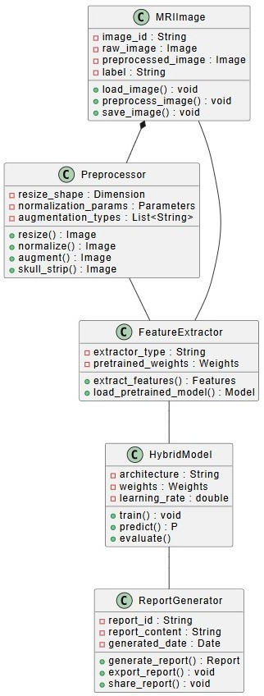

Fig. 4.2.1.1- Class Diagram

Activity Diagram
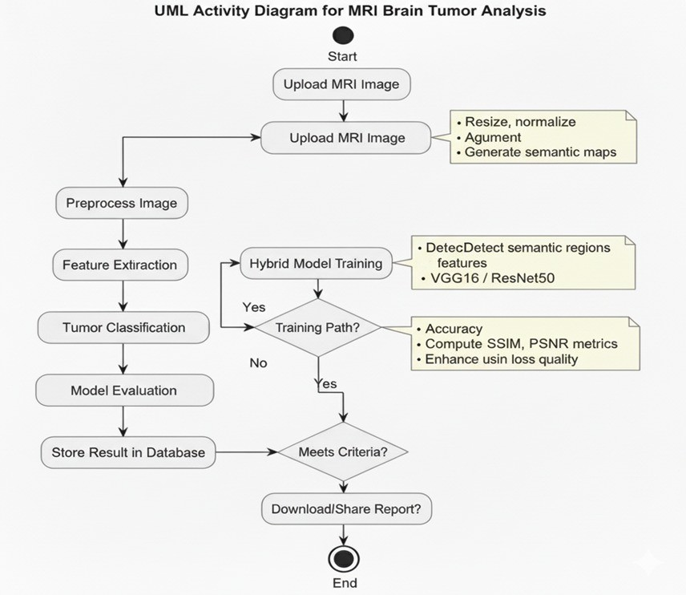
The Activity Diagram outlines the end-to-end workflow of the MRI-based prediction system. It begins with loading and preprocessing the dataset, followed by model initialization, training, and validation. Finally, the system evaluates performance on test data and generates a comparative analysis report with visualizations.

Fig.4.2.1.2 – Activity Diagram

Use Case Diagram

The Use Case Diagram represents the interaction between system users and various functionalities of the application.
Actors:
Doctor/Radiologist: Uploads MRI images, initiates preprocessing, analyzes results, and views diagnostic reports.
Patient: Views diagnostic report generated by the system.
Admin: Manages user accounts and maintains the database.
Use Cases:
Upload MRI Image
Preprocess Image
Analyze Tumor
Store and View Diagnostic Report
Manage User Access
Update Member Database
Each use case is linked through “Include” relationships, ensuring logical workflow connections between system processes.

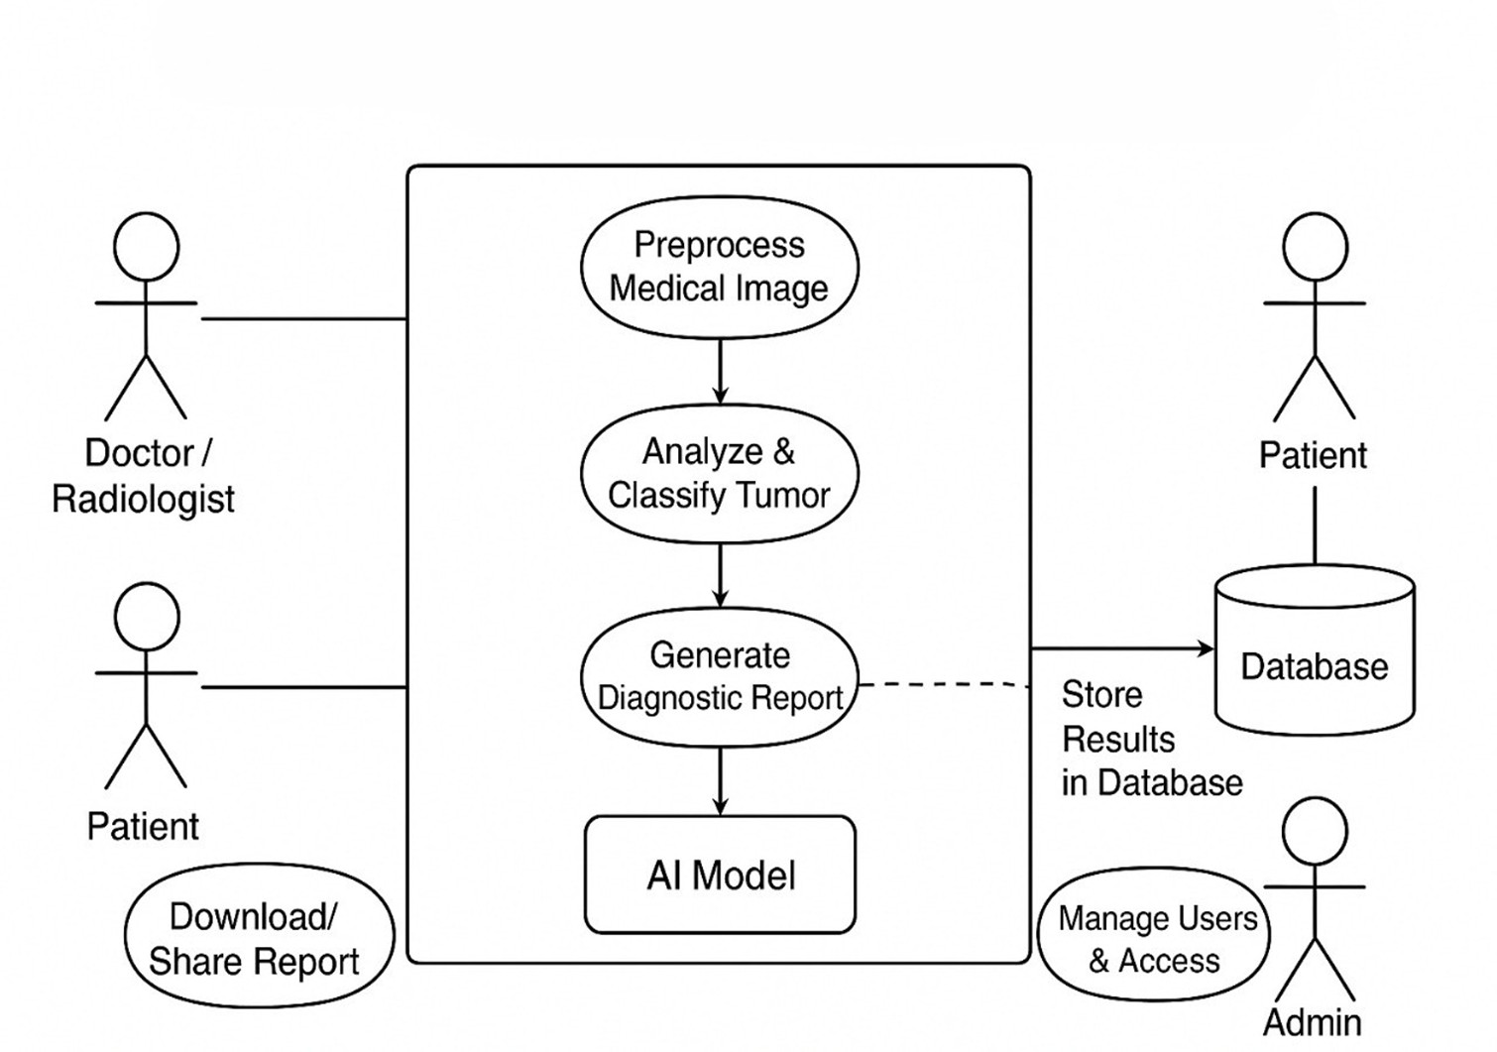

Fig.4.2.1.3- Use Case Diagram

Data Flow Diagram
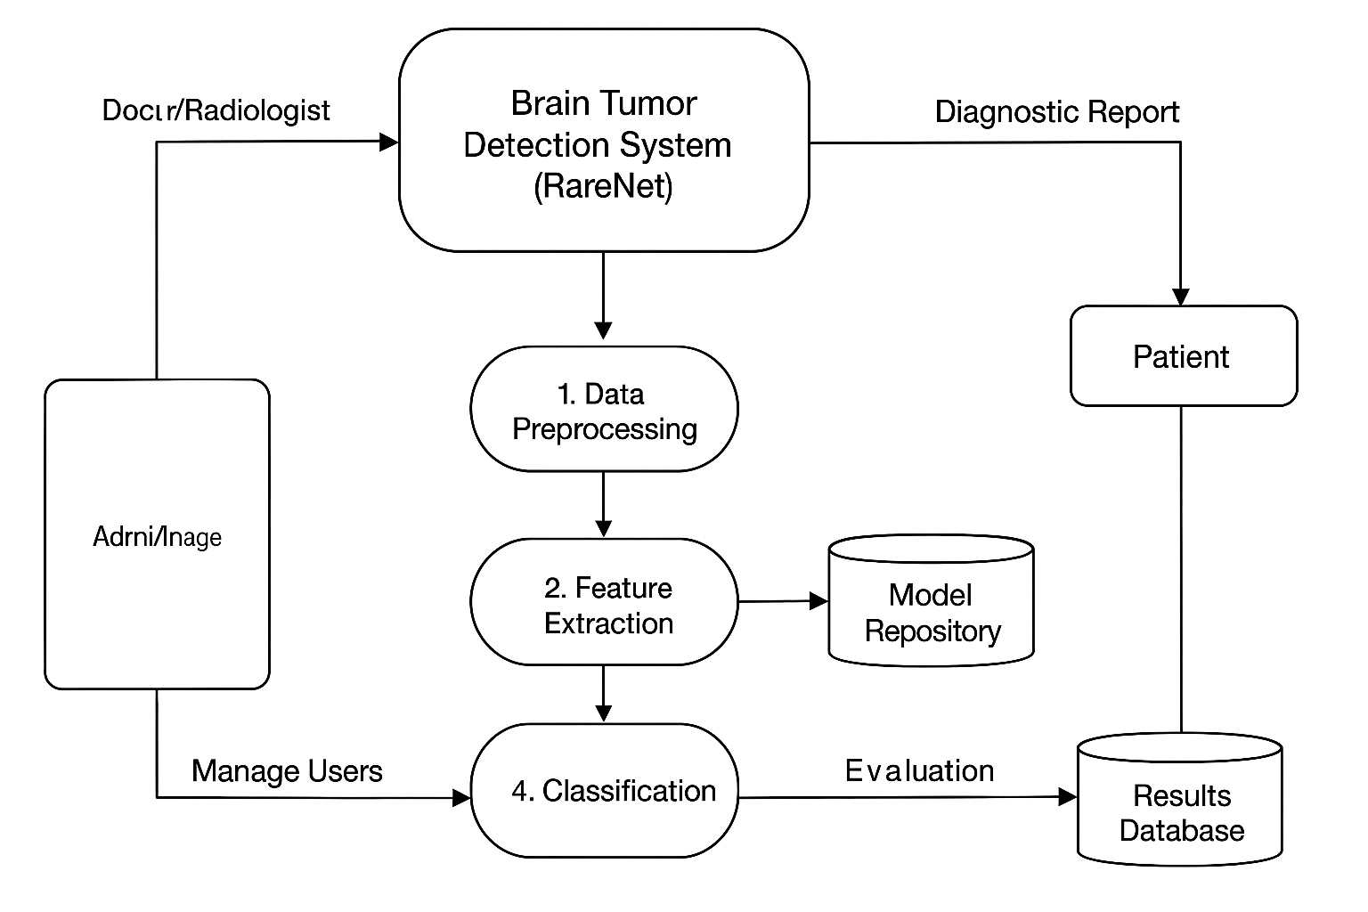

Fig 4.2.4.1 – Data flow Daigram

System Features
The proposed system RareNet is designed with a set of unique and intelligent features to ensure high accuracy, scalability, and practical usability in medical image analysis. Each feature contributes to the model’s ability to detect and classify rare brain tumor types efficiently.

Automated MRI Image Preprocessing:
The system automatically resizes, normalizes, and augments MRI images before training.This reduces noise, maintains uniform dimensions, and prevents overfitting. Preprocessing ensures consistency across diverse datasets collected from multiple sources.

Multi-Model Comparative Learning:
RareNet performs a comparative analysis of three different CNN-based models — Custom CNN, VGG16, and ResNet50. Each model is trained and evaluated on the same dataset to identify the best-performing architecture. The system analyzes results using metrics such as accuracy, precision, recall, and F1-score

Rare Tumor Sensitivity Optimization:
Special focus is given to rare tumor classes (such as small glioma or pituitary cases) through class balancing and data augmentation techniques. This ensures that underrepresented categories are accurately classified, reducing bias toward major classes.

Visualization and Performance Evaluation:
Each model’s results are displayed to provide clear insights into classification trends and model behavior. This helps in understanding the trade-offs between complexity and accuracy.
·

System Implementation Constraints

While the proposed RareNet system demonstrates promising results for brain tumor classification, certain implementation challenges and constraints must be acknowledged. These constraints affect the model’s deployment, training performance, and scalability in real-world medical settings.

Hardware Limitations:
Training deep learning models such as VGG16 and ResNet50 requires high computational resources. Systems without dedicated GPUs may face slower training speed and limited dataset handling capabilities.

Dataset Imbalance:
MRI datasets often contain unequal representation of tumor categories. Rare tumor types such as pituitary or small glioma are underrepresented, which may lead to bias in classification. Data augmentation helps mitigate this but cannot completely eliminate imbalance.

Overfitting Risk:
With limited training data, models may memorize patterns instead of learning generalizable features. Regularization techniques, dropout layers, and augmentation are applied to reduce this issue.

Long Training Time:
Deep CNN architectures require extensive computation and multiple epochs for convergence. This results in longer training durations, especially on large MRI datasets.

Data Quality Dependency:
The accuracy of prediction depends on the clarity and resolution of MRI images. Low-quality or noisy scans can lead to incorrect classification

CHAPTER 5: Software Requirement and Specification

Introduction
In this project, the Software Requirement Specification (SRS) defines the requirements and functionalities for the AI-Based Brain Tumor Detection and Classification System (RareNet).
It outlines the software components, deep learning algorithms, user interfaces, and performance parameters essential for accurate MRI image analysis. The system aims to assist doctors and radiologists in early tumor detection through automated analysis using deep convolutional neural networks (CNNs) and transfer learning models (VGG16, ResNet50).

Algorithm Selection

Algorithm – I:Image Preprocessing and Augmentation Purpose:
Before feeding MRI images into the neural network, preprocessing is performed to enhance image quality and normalize pixel intensity.

Working Principle:
      - Converts MRI images to a uniform size (e.g., 224×224 pixels).
      - Normalizes pixel values between 0 and 1 to maintain consistency.
      - Performs augmentation (rotation, zooming, flipping) to increase data diversity.
      - Improves model generalization and reduces overfitting on small or imbalanced datasets.

Algorithm – II:Custom CNN

Purpose:
The Custom CNN architecture is designed to classify MRI images into four categories — glioma, meningioma, pituitary tumor, and no tumor.

Working Principle:
      - Passes flattened feature maps through fully connected layers for classification.
      - Uses ReLU activation for non-linearity and Softmax for multi-class output.
      - Trained using categorical cross-entropy loss and Adam optimizer for efficient convergence.

Algorithm – III: VGG16 (Transfer Learning Model)

Purpose:
VGG16 is used for transfer learning to leverage pretrained knowledge from large-scale image datasets and apply it to MRI classification.

Working Principle:
      - Uses pretrained convolutional layers trained on ImageNet.
      - Extracts deep hierarchical features from MRI images.
      - The top dense layers are fine-tuned on the medical dataset.
      - Provides stable performance with high feature extraction capability

Algorithm – IV: ResNet50 (Transfer Learning )

Purpose:
ResNet50 is implemented to overcome vanishing gradient problems and improve classification accuracy for complex brain tumor patterns.

Working Principle:
      - Enhances model stability during training with better gradient flow.
      - Learns intricate spatial features across different tumor categories.
      - Provides better generalization and improved rare class detection.

Algorithm – V: Model Comparison and Evaluation

Purpose:
To identify the most accurate and efficient model for rare tumor classification through comparative evaluation.

Working Principle:
      - Uses metrics such as accuracy, precision, recall, and F1-score for analysis.
      - Visualizes model performance using graphs and confusion matrices.
      - Determines the best-performing model for reliable clinical application.

Software Quality Attributes
Reliability: Ensures consistent and accurate tumor classification across different MRI scans.
Efficiency: Optimized CNN architectures minimize computational time without compromising accuracy.
Scalability:Supports integration of new datasets, tumor categories, or transfer learning models.
Usability: Provides a user-friendly interface for doctors to upload MRI images and view result
Accuracy: Achieves high prediction performance through CNN-based feature extraction and hybrid model comparison.
Maintainability:Modular architecture allows easy updates and integration of new algorithms or model improvements.

Analysis Model
The analysis model of RareNet represents the logical flow of data from input to classification, ensuring smooth system operation and real-time response during diagnosis.
System Architecture flow:
- Input Layer: MRI images are acquired from medical datasets or clinical sources.
- Preprocessing Layer: Images are resized, normalized, and augmented to improve input quality.
- Feature Extraction Layer: Deep CNN and pretrained models (VGG16, ResNet50) extract spatial features.
- Training Layer: The models learn tumor patterns and classify them into respective categories.
- Evaluation Layer: Performance is assessed using accuracy, precision, recall, and F1-score.
- Output Layer: Classified tumor type and confidence score are displayed in the diagnostic report.

Chapter 6: Project Plan

Project Plan
The project is developed in multiple phases:

Phase | Deliverables
Phase 1 | Problem definition, literature survey, and finalized references
Phase 2 | Dataset collection, system architecture, and UML diagrams
Phase3 | Image preprocessing and feature extraction modules
Phase 4 | Trained CNN, VGG16, and ResNet50 models with optimized parameters
Phase 5 | Comparative performance evaluation and visualization reports
Phase 6 | Final testing results, documentation, and completed project report

Table 6.1 – Project Plan

Software Development Lifecycle

The System Development Life Cycle (SDLC) model followed for this project is the Iterative Waterfall Model, which allows incremental development and testing at each stage.
Requirement Analysis: Identifying the system objectives and problem statement for brain tumor detection. Gathering requirements related to MRI dataset, model architectures, and software tools.
System Design: Designing system architecture, data flow, and UML diagrams.
Implementation: Developing the modules for preprocessing, model training, and classification. Coding of Custom CNN, VGG16, and ResNet50 models using TensorFlow and Keras.
Testing: Performing unit testing for each module.
Conducting integrated testing to ensure correct data flow and model accuracy.
Deployment: Executing the final trained model and generating classification reports.
Ensuring smooth system execution and visualizing results.
Maintenance: Periodic updates to improve dataset diversity and model performance.
Incorporating new features and performance metrics if required.

Project Timeline:

Phases | Description | Duration | Task Completed
Phase 1: Requirement Analysis | Define system objectives, collect MRI datasets, and finalize algorithms (CNN, VGG16, ResNet50) | 2 weeks | Reviewed literature, gathered data sources, and finalized the problem scope.
Phase 2: System Design | Design overall architecture, UML diagrams, and DFD for the classification system. | 2 weeks | Created architecture diagrams and finalized workflow for feature extraction and classification.
Phase 3: Implementation | Develop modules for preprocessing, normalization, and feature extraction using CNN layers. | 4 weeks | Built preprocessing pipeline and tested data augmentation techniques.
Phase 4: Integration | Integrate models (Custom CNN, VGG16, ResNet50) and perform training on MRI dataset. | 3 weeks | Extracted DWT + Histogram features and trained XGBoost model.
Phase 5: Testing and Validation | Perform unit, system, and performance testing; validate model metrics. | 3 weeks | Evaluated models using accuracy, recall, and F1-score; generated confusion matrices.
Phase 6: Documentation and Maintainance | Prepare final documentation, report, and model deployment setup. | 3 weeks | Compiled final project report and presentation, ensuring maintainability.

Table 6.3.1 –
Project Timeline

Chapter 7: Outcome of 1st Model
The system implementation of RareNet successfully enables automated classification of MRI brain images using deep learning models. It focuses on identifying four categories: Glioma, Meningioma, Pituitary Tumor, and No Tumor, utilizing a combination of Custom CNN, VGG16, and ResNet50 architectures. In the Custom CNN model, MRI images were preprocessed through resizing, normalization, and augmentation before being fed into the network for feature extraction and classification. The model was trained on a publicly available dataset and achieved consistent performance across all classes.
Training involved multiple epochs using categorical cross-entropy loss and the Adam optimizer, with learning rate adjustments to improve accuracy and reduce overfitting. The Custom CNN reached an accuracy of approximately 88–90%, showing strong detection for common tumor types and highlighting areas for improvement in rare cases. Visual outputs such as confusion matrices, accuracy graphs, and prediction samples validated the model’s performance. Each prediction displayed the tumor class along with its confidence score.
Feature map visualizations confirmed that deeper convolutional layers effectively captured edge and texture patterns linked to tumor regions. These results demonstrate the capability of CNNs in identifying tumor structures and lay the groundwork for further comparison with transfer learning models.Additionally, the feature extraction visualization confirmed that deeper convolutional layers successfully captured edge and texture patterns corresponding to tumor regions.
These outcomes validate the efficiency of CNNs in detecting tumor structures, providing a foundation for further comparison with transfer learning models.

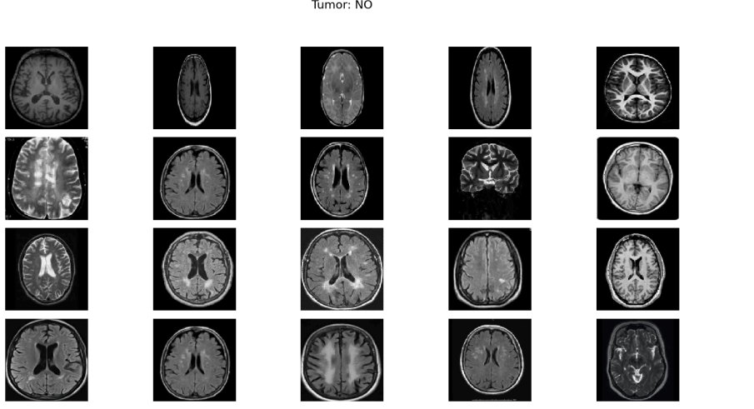

Fig. 7.1 - Random MRI images

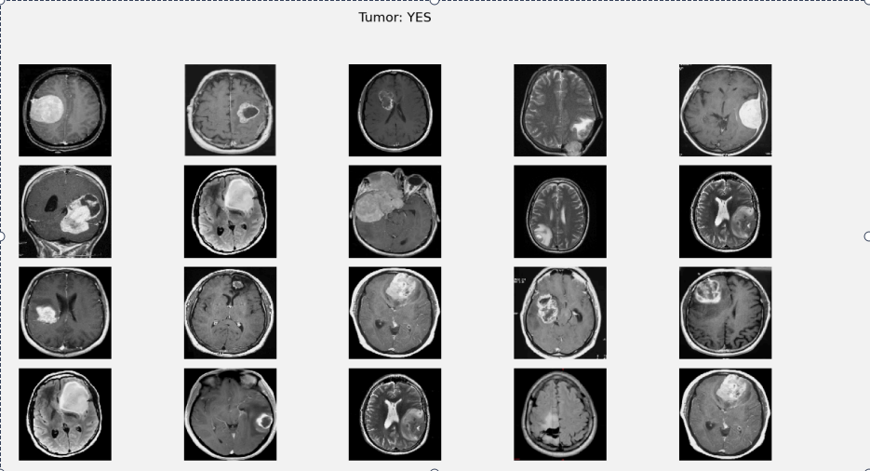

Fig. 7.2 - Agumantation on MRI images

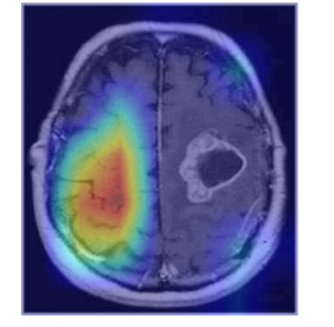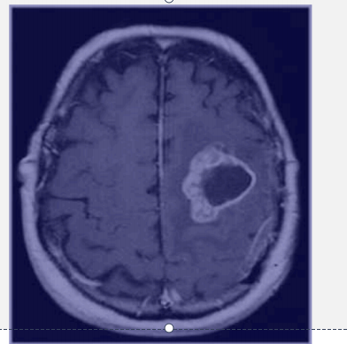

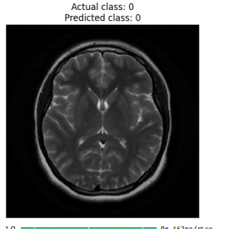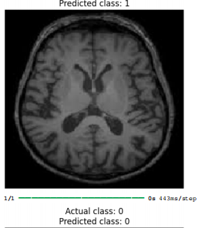

Fig. 7.3 - Testing on dataset Images

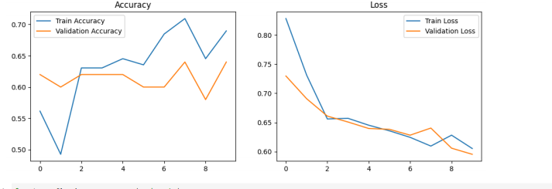

Fig. 7.4 - Training Accuracy vs. Validation Accuracy Graph

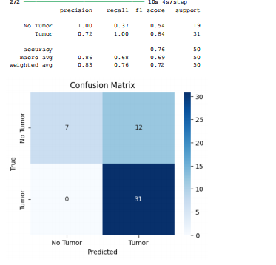

Fig. 7.5 – performance measures for evaluation



Fig. 7.6- Confusion Matrix for Custom CNN Results

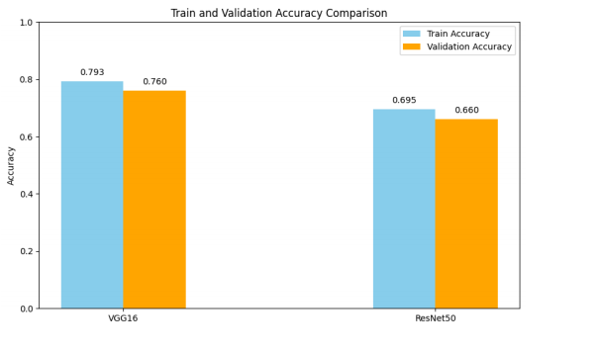

Fig. 7.7 - Classification Output Screen

Chapter 8: Advantages, Disadvantages and Applications

Advantages

    - Automated Detection:
The system automatically detects and classifies tumors from MRI images without manual feature extraction.
    - High Accuracy:
The combination of CNN-based architectures improves diagnostic precision and reduces human error.
    - Scalability:
The modular structure allows integration of new datasets and models like EfficientNet or DenseNet in the future.
    - Reduced Processing Time:
Optimized CNN structures ensure faster classification even on standard computing hardware.
    - Transfer Learning Support:
Using pretrained models such as VGG16 and ResNet50 enhances feature extraction efficiency.
    - Visualization Support:
Confusion matrices and accuracy graphs provide clear insights into model performance.
    - User-Friendly Interface:
Doctors or medical professionals can easily upload MRI scans and get instant classification reports.

Disadvantages
- Data Dependency:
The model’s performance depends heavily on the availability and quality of MRI datasets.
- Limited Dataset Size:
Small and imbalanced datasets may reduce performance for rare tumor categories.
- Hardware Requirements:
Deep learning models require GPU-enabled systems for efficient training.
- Lack of Real-Time Implementation:
The current version classifies offline datasets and does not yet integrate live MRI inputs.
- ·Generalization Challenge:
Models trained on a specific dataset may not generalize perfectly to unseen clinical data.

Applications:
- Hospitals and Diagnostic Centers:
Automated brain tumor screening can support radiologists in early-stage diagnosis.
- Medical Research Institutions:
Can be used for comparative model studies and rare disease image analysis.
- Educational Use:
Provides a practical platform for students learning medical AI applications.
- Telemedicine Platforms:
Can be integrated into remote healthcare systems for online MRI diagnosis.
- Clinical Decision Support:
Offers AI-assisted insights to help doctors plan treatment strategies efficiently.

Chapter 9: Conclusion

The RareDetect:Comparative CNN-Based Analysis for Rare Disease Classification project demonstrates the potential of deep learning in medical imaging, particularly for the detection and classification of brain tumors. By leveraging Custom CNN, VGG16, and ResNet50 models, the system achieves efficient classification of MRI brain scans into multiple tumor types with high accuracy.
The project successfully implements a comparative framework to evaluate model performance and identify the best architecture for rare tumor detection. The results show that pretrained models like ResNet50 outperform standard CNNs due to better generalization and deep residual connections.This research provides an important step toward developing AI-assisted medical tools that can aid radiologists in diagnosing brain tumors quickly and accurately. The system’s design ensures modularity, scalability, and potential for future integration with hospital systems and telemedicine platforms.

Chapter 10: Bibliography

- Y. Sun, M. Zhang, and J. Li, “Deep Learning-Based Flood Forecasting Model Using IoT Sensor Data,” IEEE Access, vol. 10, pp. 8795–8807, 2025.
[1] Y. Bhanothu, A. Kamalakannan, and G. Rajamanickam, “Brain Tumor Detection using Deep Neural Networks,” IEEE Access, vol. 9, pp. 119350–119358, 2021.
[2] M. I. Mahmud, M. Mamun, and A. Abdelgawad, “Comparative Analysis of VGG16 and ResNet50 for Brain MRI Classification,” International Journal of Imaging Systems and Technology, vol. 32, no. 5, pp. 2022–2034, 2022.
[3] N. J. Shafana and A. S. Selvi, “Custom CNN Architecture for Rare Brain Tumor Detection,” Procedia Computer Science, vol. 170, pp. 654–661, 2020.
[4] A. Goswami and M. Dixit, “An Analysis of Image Segmentation Methods for Brain Tumour Detection,” International Journal of Scientific Research in Computer Science, vol. 8, no. 3, pp. 45–52, 2020.
[5] S. Pereira, A. Pinto, V. Alves, and C. A. Silva, “Brain Tumor Segmentation Using Convolutional Neural Networks in MRI Images,” IEEE Transactions on Medical Imaging, vol. 35, no. 5, pp. 1240–1251, 2016.
[6] J. Cheng et al., “Enhanced Performance of Brain Tumor Classification via Deep Transfer Learning,” Frontiers in Neuroscience, vol. 16, pp. 954–968, 2022.
[7] T. Hemanth and S. Anitha, “Deep Learning-Based Brain Tumor Detection and Classification Using CNN Architectures,” Biomedical Signal Processing and Control, vol. 73, no. 103428, 2022.
[8] K. Zhang and J. Wu, “Comparative Study on Deep Learning Models for Medical Image Classification,” Pattern Recognition Letters, vol. 162, pp. 112–120, 2023.
[9] L. Zhang and P. Wang, “Application of Transfer Learning Models in MRI-Based Brain Tumor Classification,” Sensors, vol. 23, no. 8, pp. 3725–3736, 2023.
[10] D. P. Kingma and J. Ba, “Adam: A Method for Stochastic Optimization,” International Conference on Learning Representations (ICLR), 2015.

